# 任务单 文件存取

**任务：读写指定文件**

**（1）单击“写入内容”按钮将编辑框中的内容写入到指定文件”test.txt”中，如下图所示。**

**（2）单击”读取内容”按钮将指定文件“test.txt”中的内容读取出来显示在屏幕上，如下图所示。**

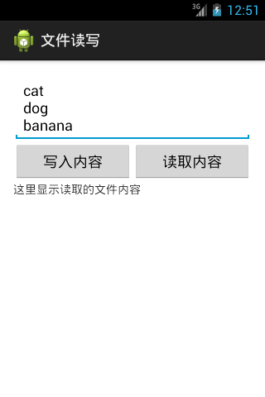

**=======提交规范=======**

**提交word文档，对应在每个任务下面提交操作结果截图，以姓名作为文件名。**

**运行截图**

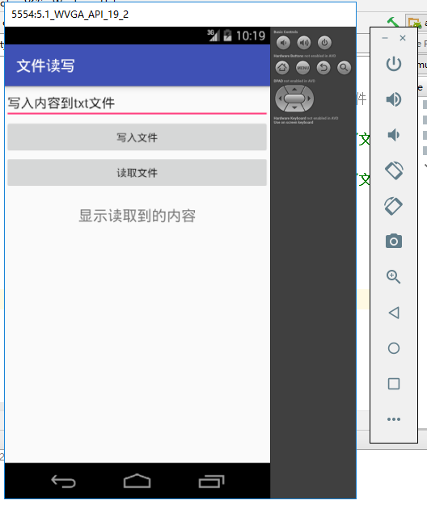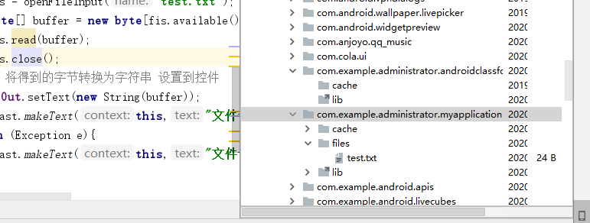

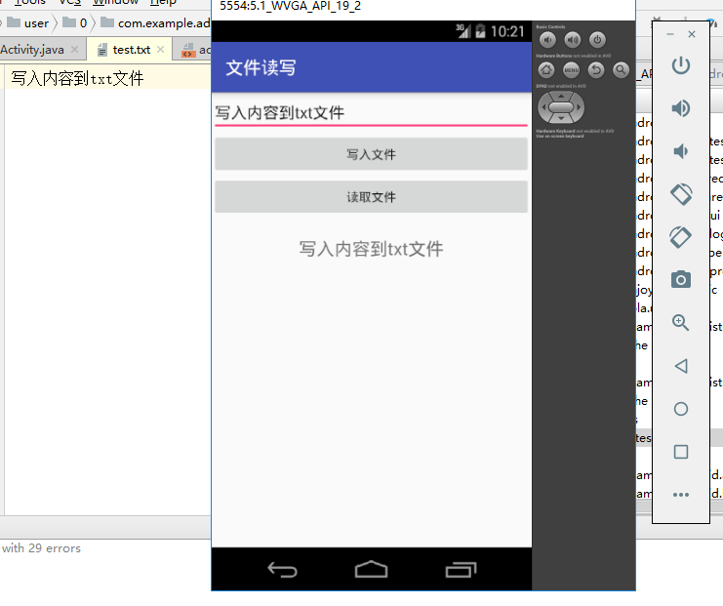

**代码：**

**MainActivity**

**package** com.example.administrator.myapplication;  
  
**import** android.app.Activity;  
**import** android.content.Context;  
**import** android.support.v7.app.AppCompatActivity;  
**import** android.os.Bundle;  
**import** android.view.View;  
**import** android.widget.Button;  
**import** android.widget.EditText;  
**import** android.widget.TextView;  
**import** android.widget.Toast;  
  
**import** java.io.FileInputStream;  
**import** java.io.FileOutputStream;  
  
**public class** MainActivity **extends** AppCompatActivity **implements** View.OnClickListener{  
 **private** EditText **edtIn**;  
 **private** Button **btnWrite**, **btnRead**;  
 **private** TextView **tvOut**;  
 @Override  
 **protected void** onCreate(Bundle savedInstanceState) {  
 **super**.onCreate(savedInstanceState);  
 setContentView(R.layout.***activity_main***);  
 initView();  
 }  
 **private void** initView(){  
 **edtIn** = findViewById(R.id.***edt_in***);  
 **btnWrite** = findViewById(R.id.***btn_write***);  
 **btnRead** = findViewById(R.id.***btn_read***);  
 **tvOut** = findViewById(R.id.***tv_out***);  
 **btnWrite**.setOnClickListener(**this**);  
 **btnRead**.setOnClickListener(**this**);  
 }  
  
 @Override  
 **public void** onClick(View view) {  
 **switch** (view.getId()){  
 **case** R.id.***btn_write***:  
 *// 输出流* FileOutputStream fos;  
 **try**{  
 fos = openFileOutput(**"test.txt"**,Context.***MODE_PRIVATE***);  
 String stIn = **edtIn**.getText().toString().trim();  
 **byte** byIn[] = stIn.getBytes();  
 fos.write(byIn);  
 fos.close();  
  
 Toast.*makeText*(**this**,**"文件读取成功"**,Toast.***LENGTH_SHORT***).show();;  
 }**catch** (Exception e){  
 Toast.*makeText*(**this**,**"文件读取失败"**,Toast.***LENGTH_SHORT***).show();;  
 }  
 **break**;  
 **case** R.id.***btn_read***:  
 *// 输入流* FileInputStream fis;  
 **try**{  
 fis = openFileInput(**"test.txt"**);  
 **byte**[] buffer = **new byte**[fis.available()];  
 fis.read(buffer);  
 fis.close();  
 *// 字节数组转换字符串* **tvOut**.setText(**new** String(buffer));  
 Toast.*makeText*(**this**,**"读取文件成功"**,Toast.***LENGTH_SHORT***).show();;  
 }**catch** (Exception e){  
 Toast.*makeText*(**this**,**"读取文件失败"**,Toast.***LENGTH_SHORT***).show();;  
 }  
 **break**;  
 }  
 }  
}

**Activity_main.xml**

*<?***xml version="1.0" encoding="utf-8"***?>*<**LinearLayout xmlns:android="http://schemas.android.com/apk/res/android"  
 xmlns:app="http://schemas.android.com/apk/res-auto"  
 xmlns:tools="http://schemas.android.com/tools"  
 android:layout_width="match_parent"  
 android:layout_height="match_parent"  
 tools:context=".MainActivity"  
 android:orientation="vertical"**>  
  
 <**EditText  
 android:id="@+id/edt_in"  
 android:layout_width="match_parent"  
 android:layout_height="wrap_content"** />  
 <**Button  
 android:id="@+id/btn_write"  
 android:layout_width="match_parent"  
 android:layout_height="wrap_content"  
 android:text="写入文件"**/>  
 <**Button  
 android:id="@+id/btn_read"  
 android:layout_width="match_parent"  
 android:layout_height="wrap_content"  
 android:text="读取文件"**/>  
 <**TextView  
 android:id="@+id/tv_out"  
 android:layout_width="match_parent"  
 android:layout_height="wrap_content"  
 android:text="显示读取到的内容"  
 android:gravity="center"  
 android:textSize="20sp"  
 android:layout_marginTop="20dp"**/>  
</**LinearLayout**>